Part B

1. Consider $H_{1}\left(Z^{D}\right)$
2. Why this filter is sometimes called an echo filter.

As seen from the graph of the impulse response, there is a Dirac delta pulse at n = 0 and a scaled replica of this pulse at n = 8, where D is 8 in this specific case. This can be considered as there is an echo at n= D. Therefore, it’s called an echo filter.

1. Find D such that echo comes 220ms after the direct sound.

Its known that $\frac{D}{F_{s}}=220ms, where F_{s}=8kHz$, therefore D = 220\*8 = 1760 samples.

The filter has been implemented in Matlab as the code below show

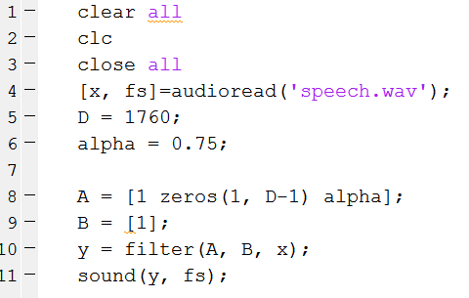

We also implement this filter with different values of $α$ and D, with a bigger alpha, the echo is louder, and a larger D result in the longer period of the echo after the direct sound.

1. To implement this filter on the DSP board, the below calculation has been carried out.

$$H_{1\left(Z\right)}=1+ αZ^{-D}$$

$$Y\left(Z\right)=X\left(Z\right)+αX\left(Z\right)Z^{-D}$$

Take the inverse Z transform, we get

$$y\left[n\right]=x\left[n\right]+ αx[n-D]$$

The C code will be demonstrated together with part (b) and (c) of this question.

1. Consider $H_{2}(Z^{D})$
2. Why this filter can be used to generate multiple echoes

Recall the impulse response coefficient for this transfer function are $α^{n}$ for all n from zero to infinity. Therefore converting the impulse response back to time domain we get $h_{2}\left[n\right]=\sum_{i=0}^{inf}{{\left(-α\right)}^{i}*δ(n-Di)}$.

This corresponded with the impulse response plot from part A of this assignment, there are pulses at every Di where i is from 0 to inf, and these pulses are scaled by the factor of ${\left(α\right)}^{i}$. And these pulses are the so-called echoes.

1. Since the requirement is still letting echoes come 220ms after the direct sound, D is still taken to be 1760 samples.

To implement this in Matlab

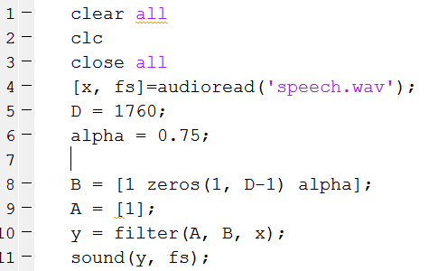

Duplicate echoes can be heard now and the loudness is higher in filter H2(Z) than H1(Z) due to the multiple echoes.

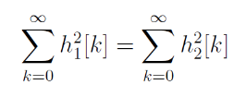

1. Let $α_{1}=0.75$ find

From the original equation, we have

$$δ{\left[0\right]}^{2}+α_{1}^{2}δ\left(D-D\right)= \sum_{i=0}^{inf}{{\left(-α_{2}\right)}^{2i}}$$

$$1+{0.75}^{2}=\frac{1}{1-α_{2}^{2}}$$

Solve the above equation gets

$$α_{2}=\frac{3}{5}, -\frac{3}{5} for \left|α_{2}\right|<1$$

Plug $α_{2}=0.6$ into the Matlab code in part (ii), we hear the loudness of echo from this filter is not as high as that in $α_{2}=0.75$.

As mentioned in (i) the echoes are scaled by ${\left(α\right)}^{i}$, this factor decides the power(loudness) of the echo.

As we change $α_{2}=1.05$, the echoes become louder and louder and finally covered the original sound. This is due to $α_{2}=1.05$ resulted in an unstable filtered and the sequence doesn’t converge anymore.

1. To implement the filter on the DSP board, the flowing conversion has been carried out

$$Y\left(Z\right)=X\left(Z\right)*H_{2}\left(Z^{D}\right)$$

$$=X\left(Z\right)*\frac{1}{1+α_{2}Z^{-D}}$$

$$X\left(Z\right)=Y(Z)(1+α_{2}Z^{-D})$$

$$convert this back to time domain, we get$$

$$y\left[n\right]=x\left[n\right]- α_{2}y[n-D]$$

The C code will be demonstrated along with that in part c of this question.